**INTRODUCTION:**

**1.Project Overview**

**Project Name:** The CRM Application for Jewel Management - Admin Project is designed to streamline jewel inventory, customer interactions, and sales tracking. It provides an efficient system for managing users, roles, profiles, reports, dashboards, and workflows within a jewelry business.

**2.Purpose:**

The purpose of the project design phase is to create a structured blueprint that defines the system architecture, data models, user flows, and technical specifications. This phase ensures that the project aligns with business requirements, enhances usability, optimizes performance, and minimizes development risks by addressing potential challenges early.

**Project Design Phase**

**Problem – Solution Fit Template**

|  |  |
| --- | --- |
| Date | 15 February 2025 |
| Team ID | LTVIP2025TMID19428 |
| Project Name | CRM Application for jewel management |
| Maximum Marks | 2 Marks |

**Problem – Solution Fit:**

The Problem-Solution Fit simply means that you have found a problem with your customer and that the solution you have realized for it actually solves the customer’s problem. It helps entrepreneurs, marketers and corporate innovators identify behavioral patterns

**Purpose:**

* Solve complex problems in a way that fits the state of your customers.
* Succeed faster and increase your solution adoption by tapping into existing mediums and channels of behavior.
* Sharpen your communication and marketing strategy with the right triggers and messaging.
* Increase touch-points with your company by finding the right problem-behavior fit and building trust by solving frequent annoyances, or urgent or costly problems.
* **Understand the existing situation in order to improve it for your target group.**

**Project Design Phase**

**Proposed Solution**

|  |  |
| --- | --- |
| Date | 15 February 2025 |
| Team ID | LTVIP2025TMID19428 |
| Project Name | CRM Application for jewel management |
| Maximum Marks | 2 Marks |

**Proposed Solution:**

|  |  |  |
| --- | --- | --- |
| **S.NO** | **Parameter** | **Description** |
| **1.** | Problem Statement (Problem to be  solved) | Managing jewelry inventory, customer relationships, and sales  tracking manually is inefficient. Lack of automation leads to  errors, poor customer engagement, and difficulty in tracking  stock and orders. |
| **2.** | Idea / Solution description | A cloud-based CRM application tailored for jewel management  that streamlines inventory tracking, sales management,  customer engagement, and reporting. It includes features like  role-based access, dashboards, automated workflows, and  seamless user experience with Lightning app support. |
| **3.** | Novelty / Uniqueness | Unlike generic CRMs, this solution is specifically designed for  the jewelry industry, incorporating custom modules for jewelry  inventory, valuation tracking, and authentication. It integrates  advanced reporting and AI-driven customer insights for better  decision-making. |
| **4.** | Social Impact / Customer Satisfaction | Enhances customer satisfaction by providing personalized  recommendations, efficient order processing, and improved  customer service through automated workflows and  engagement tracking. |
| **5.** | Business Model (Revenue Model) | Subscription-based model with tiered pricing for different  business sizes. Additional revenue from premium features  such as AI-powered analytics, integration with e-commerce  platforms, and advanced reporting tools**.** |
| **6.** | Scalability of the Solution | Built on a cloud-based infrastructure, ensuring scalability for  small jewel retailers to large enterprises. Supports multi-user  access, role-based security, and seamless integration with  third-party tools for future expansion. |

**Project Design Phase**

**Solution Architecture**

|  |  |
| --- | --- |
| Date | 15 February 2025 |
| Team ID | LTVIP2025TMID19428 |
| Project Name | CRM Application for jewel management |
| Maximum Marks | 4 Marks |

**Solution Architecture:**

Solution architecture is a complex process – with many sub-processes – that bridges

the gap between business problems and technology solutions. Its goals are to:

● Find the best tech solution to solve existing business problems.

● Describe the structure, characteristics, behavior, and other aspects of the

software to project stakeholders.

● Define features, development phases, and solution requirements.

● Provide specifications according to which the solution is defined, managed,

and delivered.

**Example - Solution Architecture Diagram:**

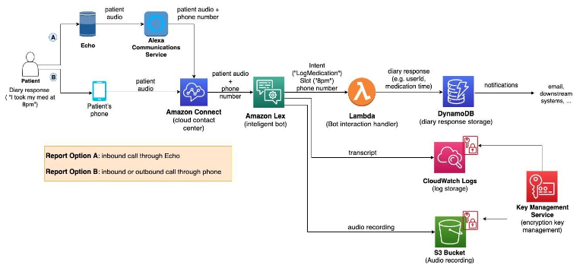

**CONCLUSION:**

The CRM Application for Jewel Management - Admin Module aims to streamline administrative tasks, enhance user role management, and improve overall system efficiency. By addressing key challenges such as user adoption, security, reporting, and workflow automation, the system ensures that jewelry businesses can efficiently manage customers, sales, inventory, and employees. With role-based access control, automated processes, and insightful dashboards, the solution empowers admins, managers, and employees to work more effectively. A well-structured implementation plan, training modules, and continuous feedback mechanisms will drive successful adoption and long-term efficiency in jewelry businesses

**THANKYOU SMARTBRIDGE**

**B. NAGA SAI LAKSHMI KAMALA**

**TEAM LEADER**